**Ava’s Mission to Space**

***Technical Documentation:***

***Overview:***

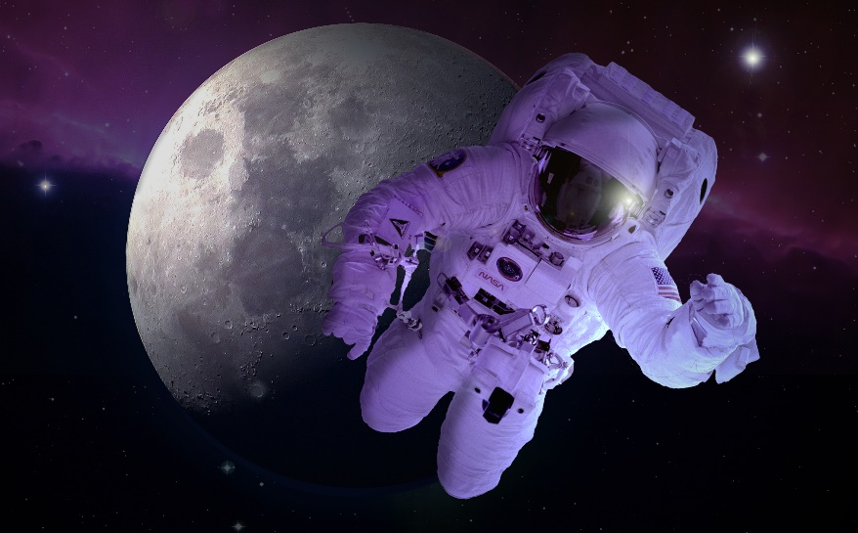Ava's mission is a story about a girl who volunteers to be the extra person to help the NASA team go to space and help downsize the comet that is heading towards earth. Ava must go through training to prep for this mission, training on vision, quick reflexes, and instincts.

There are 5 chapters and each one is consider a test, in order to proceed to the final chapter a player my complete and pass each chapter.

Ava's mission is under IDLE (Python 3.10) file and is run by python.

(This game language is python (No other program language!)

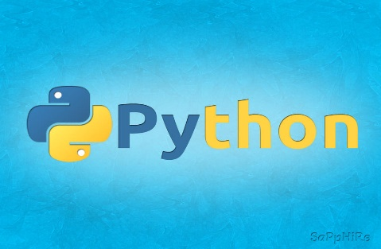

[This Photo](https://sapphiregd.deviantart.com/art/Wallpaper-Python-331815540) by Unknown Author is licensed under [CC BY-NC-ND](https://creativecommons.org/licenses/by-nc-nd/3.0/)

***Important Note: There is no external service for this game***

***Coding & Naming Conventions***

*The functions are simple and easy. It's a matter of this or that or yes or no. All questions provide an answer, and all answers must be written as shown.*

*For example:*

*Question is "The spacecraft be protected by either Metal or Plastic, which material will the spacecraft be?*

*Correct answer is “Metal”, if metal is written with a lowercase “m”, it will not accept the prompt. Same with all answers will be completed as shown.*

***Flowchart***

***Chapter 1***:

As Ava walks into the concealed lot, there are three giant rooms;

While the safety team & observers are behind a room looking through

a clear glass taking notes;

At this point the only thing the player must do is accept the responsibilities

& agree to train to this important mission. It’s either a yes or no question.

***Chapter 2:***

Ava is being prepared about the importance of being appropriately equipped & carefully.

Her trainer goes over each part of her space backpack, explaining what is needed &

connected to the spacesuit***.***

Player must assembler their spacesuit. Each room/box has the correct items.

Player must pick the right one, if not, player cannot proceed with the next level/chapter.

***Chapter 3:***

Excited to be at this level, Ava feels fearless & eager about

how she’s been able to train so far.

She is ready for her next training session.

This chapter player must match objects shapes with its matching color.

***Chapter 4:***

In this level, player will get train on their fast reflexes &

be able to train on how & when to shoot their gun.

Giving that player is going to space, we don’t know what we will

encounter therefore, we must be ready for anything.

Player will see if they will “Shoot to Kill” or “Hold fire”.

This is an important test since player is putting their life on the line.

***Chapter 5: Last & final level/test***

Finally in space, decided rather they will either shoot the comet

to make it smaller to make the impact less, player will

put their faith in their hands. Choice is giving to them if they will live or die.

***Support Information:***

Please contact the numbers below in regard to any system errors: suggest to restart to run the program if not contact below….

Game glitches or errors contact via email or phone number:

Email: [avasmission@gmail.com](mailto:avasmission@gmail.com) (fake)

Phone number: 1- 800 – 985-0021 (fake)